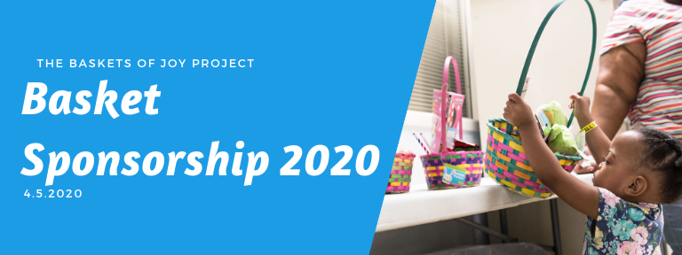
1,500+ Easter Baskets given to kids in need!

Baskets are provided to area shelters and outreach organizations including: Women and Children’s Horizons, Shalom Center, Halo Inc., Women’s Resource Center-Racine, Transitional Living Center, Safe Haven/Girls Inc, Boys and Girls Club Kenosha, ELCA Outreach Center and Professional Service Group-Kenosha

Our Easter baskets promote physical activity/outdoor play, creativity, and build self-esteem by allowing children to have the tools of play that they so desperately need.
Sponsor Benefits  Sponsorship commitments due by March 1st, 2020 | Platinum Sponsor  $1,000+ | Gold Sponsor $500-999 | Silver Sponsor  $250-499 | Bronze Sponsor  $100-249
Name announcement during the assembly event
Option to provide promotional items to recipients/event volunteers*
Name mention on facebook event page
Name mention on Baskets of Joy Project facebook page
Logo with link on Basket of Joy Project website
Logo printed on event flyer (distributed to volunteers at assembly event)
Sign or banner prominently displayed at event
(must be provided by sponsor)
*Give-aways must be child appropriate and must be beneficial to the recipient in some way.
No political affiliated or drug/alcohol related items allowed.
Items must be approved by event organizer, Quinn Gasparo prior to event.

Contact Quinn Gasparo at basketsofjoyproject@gmail.com to become an event sponsor! https://www.facebook.com/basketsofjoyproject/ http://basketsofjoyproject.wixsite.com/home

Baskets of Joy Project
Easter Basket
Sponsor Commitment Form
April 5th, 2020

Please complete the sponsor commitment form and return a scanned copy to:
Quinn Gasparo, Baskets of Joy Founder at basketsofjoyproject@gmail.com

Payment Deadline: March 1st 2020

Business/Organization Name:__________________________________________________________________

Contact Name: _____________________________________________________________________________

Mailing Address: ____________________________________________________________________________

City:_____________________________ State: ____ Zip:_______ Phone Number: ____________________

Email Address: ______________________________________________________________________________

Business Website:____________________________________________________________________________

Facebook Page URL:__________________________________________________________________________

Sponsorship Level (circle one):

Platinum Sponsor: $1000+ Gold Sponsor: $500+ Silver Sponsor: $250+ Bronze Sponsor: $100+

Payment is made via check and is due by March 1st 2020.

Checks are written out to:
ELCA Outreach Center

In the ‘memo’ section write: Baskets of Joy Project

Checks may be dropped off at the ELCA Outreach Center or mailed to:

ELCA Outreach Center
Attention: Baskets of Joy Project
6218 26th Avenue
Kenosha, WI 53143

*If funds are received in excess of what is required to provide Easter baskets to recipient organizations, funds may be utilized at the discretion of the Baskets of Joy project to benefit local children in need

I have read and fully understand the parameters of my sponsorship. I agree to complete payment in accordance with my selected sponsorship level by the deadline of March 1st, 2020.

Signature: _______________________________________________ Date:___________________

