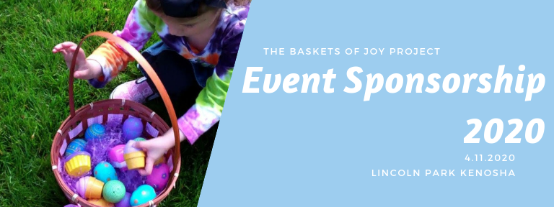
Over 8k eggs, fun prizes, and a visit from the Easter bunny makes our Easter egg hunt a blast!

We have separate hunts for children 0-3, ages 4+ as well as a ‘sensory friendly’ Easter egg hunt for our friends who may require special accommodations.

Our Easter egg hunt is inclusive of children of all abilities!

More than 300 children will be in attendance with their families, making this event a great opportunity for community involvement!
Sponsor Benefits  Sponsorship commitments due by March 1st, 2020 | Platinum Sponsor  $1,000+ | Gold Sponsor $500-999 | Silver Sponsor  $250-499 | Bronze Sponsor  $100-249
Name announcement during the event
Option to provide promotional items to participants*
(no table provided)
Name mention on facebook event page
Name mention on Baskets of Joy Project facebook page
Logo with link on Basket of Joy Project website
Logo printed on event flyers (distributed prior to the event)
Logo printed on flyer distributed at the Easter egg hunt
Table rights at event (for activities or give-aways)*
Sign or banner prominently displayed at event
(must be provided by sponsor)
*Give-aways and activities must be child appropriate and must be beneficial to the participant in some way.
No political affiliated or drug/alcohol related items allowed. No sales of any kind. Items must be approved by event organizer, Quinn Gasparo prior to event. This event is held rain-or-shine! Tables are not covered.
Sponsors may bring their own tent if desired.
Contact Quinn Gasparo at basketsofjoyproject@gmail.com to become an event sponsor! https://www.facebook.com/basketsofjoyproject/ http://basketsofjoyproject.wixsite.com/home

Baskets of Joy Project
Easter Egg Hunt
Event Sponsor Commitment Form
April 11th, 2020

Please complete the sponsor commitment form and return a scanned copy to:
Quinn Gasparo, Baskets of Joy Founder at basketsofjoyproject@gmail.com

Payment Deadline: March 1st 2020

Business/Organization Name:__________________________________________________________________

Contact Name: _____________________________________________________________________________

Mailing Address: ____________________________________________________________________________

City:_____________________________ State: ____ Zip:_______ Phone Number: ____________________

Email Address: ______________________________________________________________________________

Business Website:____________________________________________________________________________

Facebook Page URL:__________________________________________________________________________

Sponsorship Level (circle one):

Platinum Sponsor: $1000+ Gold Sponsor: $500+ Silver Sponsor: $250+ Bronze Sponsor: $100+

Payment is made via check and is due by March 1st 2020.

Checks are written out to:
ELCA Outreach Center

In the ‘memo’ section write: Baskets of Joy Project

Checks may be dropped off at the ELCA Outreach Center or mailed to:

ELCA Outreach Center
Attention: Baskets of Joy Project
6218 26th Avenue
Kenosha, WI 53143

*If funds are received in excess of what is required to hold the Easter egg hunt, funds may be utilized at the discretion of the Baskets of Joy project to benefit local children in need

I have read and fully understand the parameters of my sponsorship. I agree to complete payment in accordance with my selected sponsorship level by the deadline of March 1st, 2020.

Signature: _______________________________________________ Date:___________________

